Background
- Climate (impact) research relies on high quality (temporal and spatial resolution) data of weather variables (Tmax, Tmin, Precipitation)
- Distribution of meteorological stations is sparse and uneven
- Gauge measurements have several drawbacks, such as incomplete areal coverage and deficiencies over most oceanic and sparsely populated areas (Kidd et al., 2017; Rana et al., 2015; Xie & Arkin, 1996).
- Lu 2018 - gauges have difficulty in representing areal rainfall over a large region due to the inherent limitation of point measurements (Groisman and Legates 1994; Sinclair et al. 1997).
- Lu 2018 - the accuracy of satellite precipitation products is generally lower than that of ground-based observations because of the indirect nature of observations, sampling error, retrieval algorithm uncertainty, and other factors (Ma et al. 2014; Yang and Luo 2014a).
Model Physics
- Precipitation is not directly assimilated in the reanalysis and refined datasets; however, some observations, such as the temperature and humidity, are used to initialize the forecast model; hence, the accuracy of the model simulation primarily depends on the quality of the model physics (Zhang et al., 2013).
- Sun 2017 – The idea behind reanalysis systems is to merge irregular observations and models that encompass many physical and dynamical processes in order to generate a synthesized estimate of the state of the system across a uniform grid, with spatial homogeneity, temporal continuity, and a multidimensional hierarchy
Datasets
- Gridded datasets for Precipitation and Temperature can be categorized into three main categories namely, (i) Gridded dataset obtained after geostatistical interpolation of ground-based observations (Interpolated datasets), (ii)Dataset generated by merging observations with model outputs, i.e. reanalysis datasets, (iii)Datasets derive by satellite-based observations (remote sensing) (LutzandImmerzeel2016)
- APHRODITE
  - Gauge-rich and homogenous since 1951, offers Asia’s most observation-based daily precipitation records but lacks post-2015 updates, high-elevation gauges, fine spatial resolution, and multi-variable coverage.
  - Aphrodite though known to be the best dataset to represent precipitation over Himalayas, its accuracy is limited by sparse observations over high altitudes (Lutzetal2014). It was also reported that APHRODITE has no single station over elevations > 5000m amsl which makes this product non suitable for elevations above 5000m amsl (Kumaretal2015).
  - For temperature magnitude, it was observed that interpolated and reanalysis datasets like CRU-TS,ERA-I, PGF and UDEL outperformed APHRODITE at all zones which could be attributed to lesser complexity in temperature estimation as compared to the precipitation over mountainous regions.
In case of precipitation, the highest overestimation/wet bias was shown by ERA-I at all zones. This overestimation by ERA-I over high altitudes has previously been reported by many researchers in the past (Palazzi et al 2013, Tong et al 2013, Immerzeel et al 2015, Dahri et al 2016).
- Shrestha 2022 - The two widely used approaches for climate model selection are the skill-based approach and envelop approach.

Comparison of gridded and observation data
- Spatial interpolation techniques for point observation data: Inverse Distance Weighing (IDW) and Co kriging
- Regression Kriging for merging corrected gridded data – Waongo 2024
- Hong 2021 – Random forest, one of the machine learning approaches, outperforms the bilinear interpolation in downscaling precipitation data and can reproduce reasonable spatiotemporal patterns of precipitation across North America (He et al. 2016).
- Dhmane 2023 - ,previous studies have compared pixel-to-pixel and pixel-to-point interpolation techniques and have found that they lead to similar conclusions.

Assessment Metrics
- Conventional metrices: RMSE, r2, Bias, Nash-Sutcliffe Efficiency (NSE), Kling-Gupta Efficiency (KGE)
- Dangol 2022 - Categorical statistical indices such as accuracy (ACC), probability of detection (POD), false alarm ratio (FAR), critical success index (CSI), and frequency bias index (FBI)
- Model Skill Scores assess how well climate models reproduce historical patterns and variability by considering both correlation and distribution, unlike conventional metrics (means, SDs) that only capture limited aspects of data. Taylor’s score evaluates correlation and variability, Perkins’ score measures PDF overlap (for temperature), and Sanchez’s score compares CDFs through multiple distributional factors (for precipitation). These are combined into equally weighted temperature and precipitation skill scores, then averaged for an overall model score (1981–2005). Using such distribution-based methods is crucial because traditional statistics can miss differences in pattern or frequency (e.g., Anscombe’s quartet), while skill scores ensure models realistically capture both average conditions and extremes.
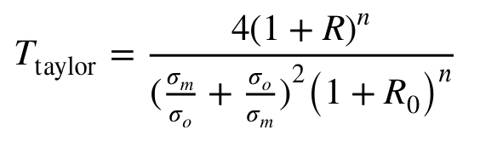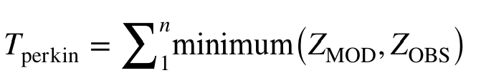
- After the use of multiple statistical metrics, most suitable dataset is decided based on methods such as multi-criteria decision-making, compromise programming index (CPI)
- Dangol 2022 - Two widely used approaches for validation/evaluation of SPPs are the following (Tong et al. 2014): (a) direct comparison of SPPs with observed gauge data (Abd Elhamid et al. 2020; Ghaemi et al. 2021; Hamal et al. 2020; Masood et al. 2020; Sharma et al. 2020a; Zhang et al. 2020) and (b) evaluation through hydrological modeling scheme based on their anticipating ability of streamflow
- Kanda 2020 – The most commonly used MCDM (Multi-criteria Decision Making) method is Weighted Sum Model (WSM) but many advanced methods like Weighted Product Model (WPM), the analytic hierarchy process(AHP) and compromise programming are becoming more popular these days (Triantaphyllou 2000, Salman et al 2018).
Bias Correction
- Tanimu 2024 - … to correct systematic inaccuracies, enhancing their alignment with observed data (Maraun 2016; Worako et al. 2022).
- Dangol 2022 - For bias correction of the SPPs, Chen et al. (2013) classified bias correction methods into two categories: (a) mean-based approaches and (b) distribution-based approaches.
- Depending upon the case, even simple bias correction methods such as linear scaling outperform complex bias correction techniques.
- Tanimu 2024 - Luo et al. (2018) have also demonstrated that no universally applicable BC method can be effectively implemented in all regions.
- Maraun 2016 - As almost all state-of-the-art bias correction methods are deterministic, they cannot generate this random variability; variance correcting methods such as quantile mapping may inflate extreme events
Bias Correction Methods
- Tanimu 2024 - Machine learning (ML) has a notable advantage in uncovering meaningful insights within the climate system through pattern identification and feature extraction methodologies. Hence, the utilization of ML in BC has experienced significant attention in recent times. (Cho et al. 2020; Hieronymus 2023; H. Kim et al. 2021; Ling et al. 2022). However, it has been observed that ML algorithms can lead to inaccurate estimation due to overfitting during training (Seo & Ahn 2023)
- Power transformation - uses a nonlinear approach in the form of exponential, e.g., logarithm, square root, etc., to make GCMs and observed data comparable. P∗ = aP^{b}
- Generalized quantile mapping - represents an expansion of quantile mapping, utilizing a more adaptable mapping function accounting for possible nonlinearity within the dataset (Cannon et al. 2015). It employs an overall Pareto distribution (GPD) to values over the threshold and a gamma distribution to values below the threshold (Heo et al. 2019; D.I. Kim et al. 2019)
- Scaling method - multiplication factors and additional terms are employed in the correction of rainfall and temperature, respectively, and these corrections are applied every month (Lafon et al. 2013).
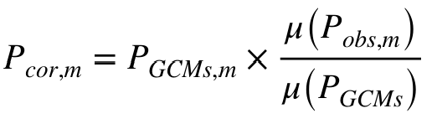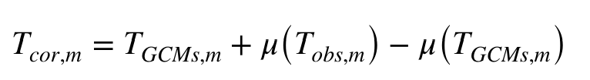
- Empirical quantile mapping- model's cumulative distribution function (CDF) is fitted to that of observation data (Enayati et al. 2021; X. Li & Babo vic 2019).
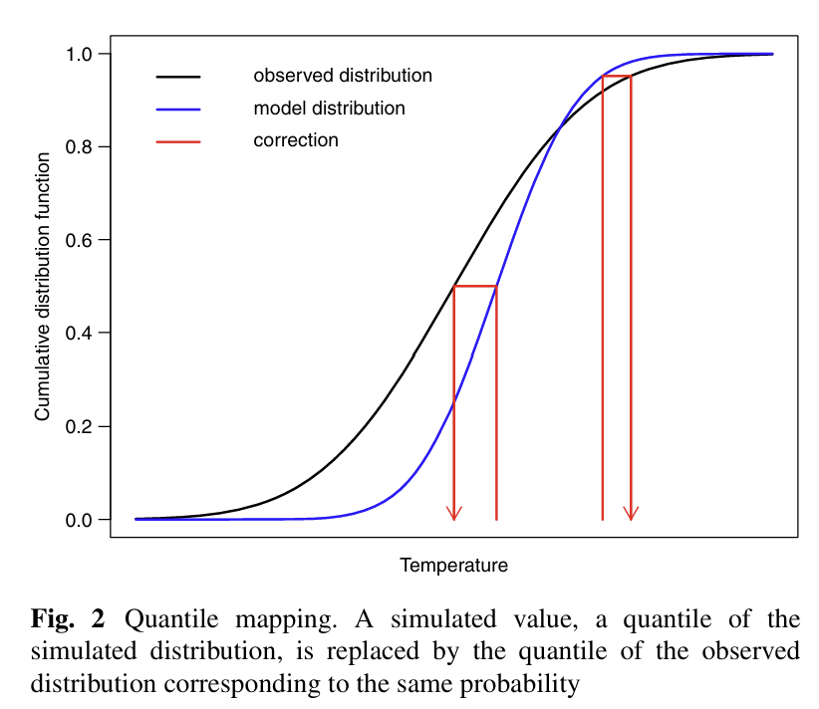
- Delta change method - focuses on calculating the climate change anomaly (the "delta") between future and historical GCM simulations and imposing this anomaly onto the observation record.
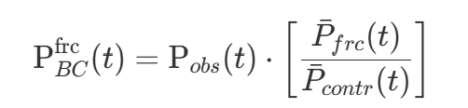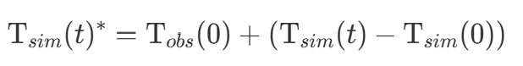
- Quantile delta mapping - changes (deltas) in quantiles between historical observed data and the future projections of climate models (Casanueva et al. 2020; Gori et al. 2022).
- Variance scaling - corrects biases in climate models and improves local scale projections by adjusting the variability of climate model data to match that of observed historical data (Maraun 2016). Assumption: Biases in climate models that may underrepresent climatic variability are addressed via variance scaling (Maraun et al. 2010)
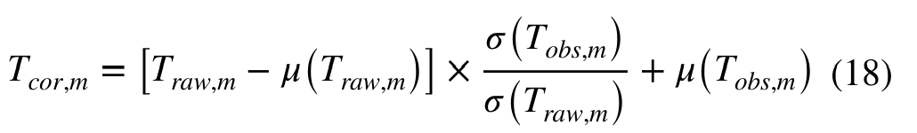
- Mean and variance adjustment - adjusts the variance and the mean of climatic model data to align with those of reference observed historical data (Gutjahr & Heinemann 2013; Wilcke et al. 2013).
- Detrended quantile mapping - first removes the long-term trend from both observed and simulated data, applies standard quantile mapping to the detrended values, and then adds the trend back to the corrected data.
- Artificial neural networks - regression-based statistical techniques used to establish complex, nonlinear relationships between GCM simulated variables (predictors) and local climate variables (predictands) (Nourani et al. 2019).
- Random forest - combines the output of multiple decision trees, generated from a bootstrap sample, to arrive at a single result (Raczko & Zagajewski 2017).
- Support vector machines - create hyperplanes that effectively separate data points by maximizing the margin, providing flexibility in accurately fitting the data.

Downscaling
- Tanimu 2024 - Methods for downscaling include statistical and dynamical techniques.
- Dynamic approaches - utilize GCMs as a fundamental tool for modeling physical processes and boundary conditions.
- Statistical downscaling - involves establishing a correlation between the large-scale factors simulated by GCMs and the local climate patterns to predict local climate variables (Vogel et al. 2023). - more prevalent in recent years due to their advantageous characteristics, such as computing efficiency, simplicity, and ability to provide localized climatic data at specified geographical locations (Su et al. 2013; Zhang et al. 2022).
- Arshad 2021 - On the other hand, geographical weightage regression (GWR) model investigates the non-stationary and scale- dependent characteristics of the association among dependent and independent variables (Foody, 2003)
- Mishra 2020 - The primary limitation of the dynamical downscaling is related to the requirement of computational efforts to run the regional climate models at higher spatial and temporal resolution.

High altitude regions
- The precipitation pattern in a mountainous region is inherently complex because of interactions between the terrain and atmosphere.
- Shrestha 2017 - For the steep gradient topography of Himalayan basins, estimates of these climate variables can be even more questionable, requiring validation with observed data and use of some form of correction before any application and analysis of climate driven hydrology into the future.
- high-resolution simulations can resolve more orography and yield better simulation results than low-resolution simulations (Lin et al., 2018).
- High-elevation regions have relatively warm clouds. Incorrect discrimination between raining and non-raining clouds with thermal IR could cause the IR rainfall retrieval algorithms to miss light-precipitation events and underestimate total rainfall (Bitew & Gebremichael, 2010; Maggioni et al., 2016). Conversely, reanalysis data sets tend to overestimate precipitation at higher elevations compared with observations from stations. For instance, compared with the station observations from China Meteorological Administration and the U.S. National Snow and Ice Data Center, MERRA, ERA-Interim, and CFSR significantly overestimate precipitation at high elevations; however, the TRMM 3B42 satellite data underestimate precipitation in mountainous areas in Central Asia (Hu et al., 2016).
- Oukaddour 2015 - The problem of the altitude and orography effects is challenging for all the examined products. Our analysis shows clearly that the precipitation estimates deviate from gauge data as moving from the plain to the piedmont and more importantly to the mountains. This problem was previously reported by other studies (Chen et al. 2021; Dubey et al. 2021; Araghi and Adamowski 2024).
- The high-resolution datasets can better represent the terrain effect, moisture transport and precipitation process in a mountainous region; thus, ERA5-L and ERA5 show a more consistent spatial pattern of observed precipitation than that of coarse resolution ERA-Int
- High-resolution simulations present a steeper and rougher land surface like that of areal terrain; therefore, they better represent topography-induced effects and orographic precipitation (Wang et al., 2020b).
- ERA5-L and ERA5 largely overestimated the monsoonal precipitation in the eastern region, in contrast to the western region, suggesting that the ERA5 and ERA5-L simulations with high-resolution effectively reflect the blocking effects of the terrain and dam more water vapor from the Bay of Bengal in the eastern region, therefore allowing less water vapor transport into the western region (Chen 2021)
- Yin 2008 - In an earlier study (Yin et al. 2004), it was found that the SSM/I-based rainfall estimates can be significantly improved by incorporating topographic and geographic location variables
- Hong 2021 - Reanalysis data may not perform well in complex terrain, implying the necessity of considering environmental impacts (Liu et al. 2018)
- It is not enough to consider only the bias caused by the orographic effect over this region, because uncertainty in precipitation estimation in the TP is also affected by environmental factors (Shen et al. 2014a; Zhang et al. 2018)
- Lu 2018 -It is well known that topography has a notable effect on precipitation (Smith 1979; Roe et al. 2002; Guan et al. 2005; Crochet 2009; Shige et al. 2013, 2014; Yamamoto and Shige 2015). Incoming moisture is forced to rise by mountains and hills, leading to more rainfall on the windward side and less rainfall on the leeward side (Barros and Lettenmaier 1992, 1994; Michaud et al. 1995).
- Chen 2021 - in the mountainous regions with a complex topography, the spatial resolution plays an important role in representing the effects of an orographic gradient on a precipitation simulation

Climatology of Nepal
- Nepal has four climatological seasons: the pre-monsoon season (March-May), summer monsoon season (June-September), post-monsoon season (October-November) and winter season (December-February) (Nayava, 1980)
- The South Asian monsoon contributes 97% of the annual precipitation during the monsoon seasons, while the remaining 3% of the precipitation occurs in the winter because of the influence of the westerlies system (Hamal, 2020).
- The spatial distribution of the precipitation is primarily determined by the interaction of natural controls, such as the latitude, elevation, and slope as well as an orographic influence (Smith and Barstad, 2004; Blocken et al., 2006).

